Data Structures Practical assignment done by vaishnavi,192224049

1.fibonacci series

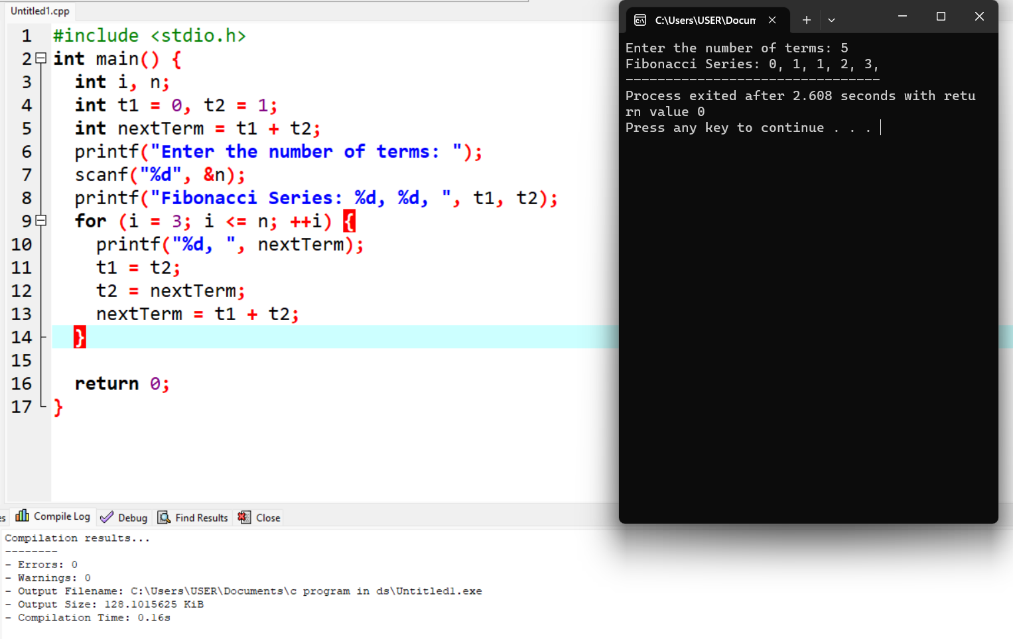

# 2. LINEAR SEARCH METHOD

# 3.BFS

# 

4.DFS

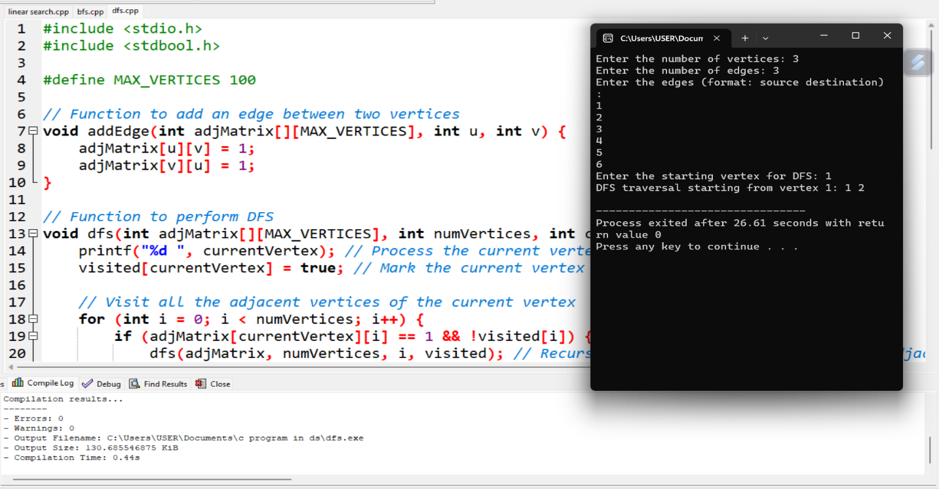

5. dijkstra’s algorithm

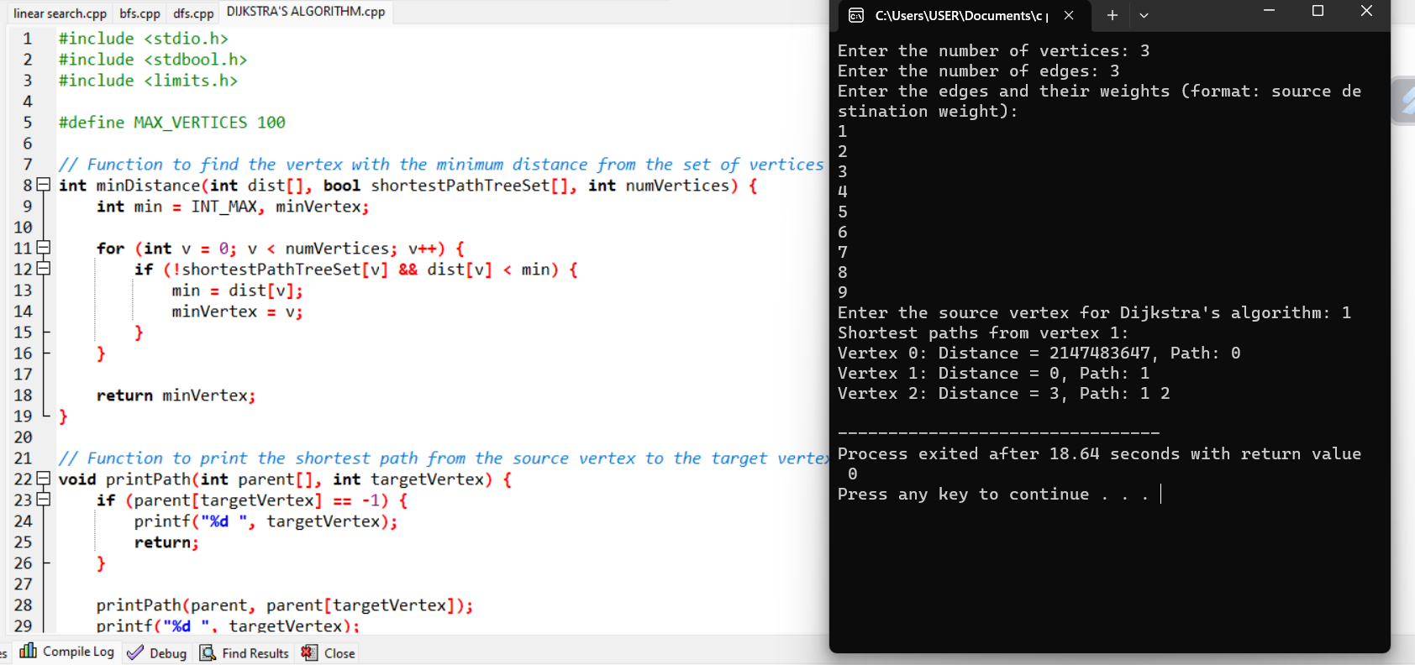

6. even or odd

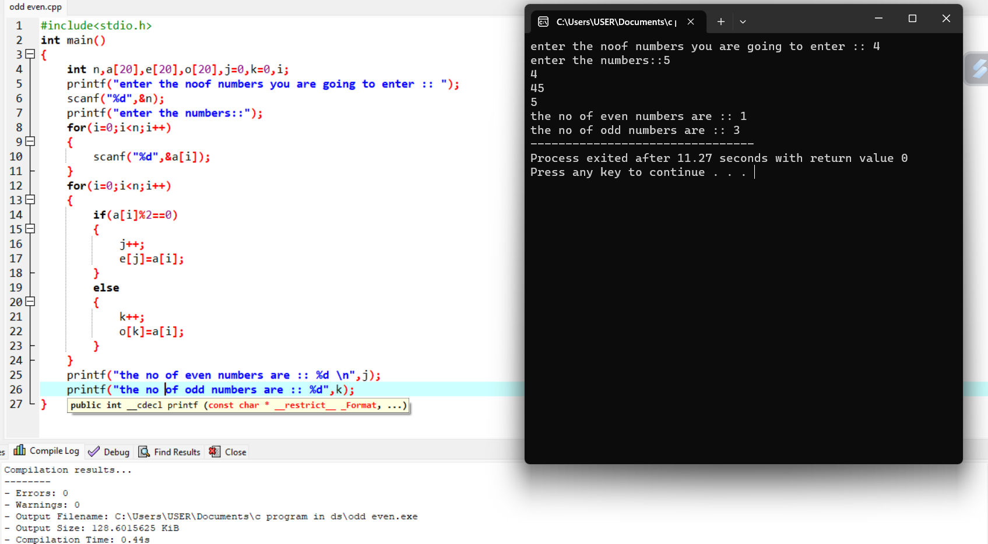

# 7. FABONACCI USING RECURSION

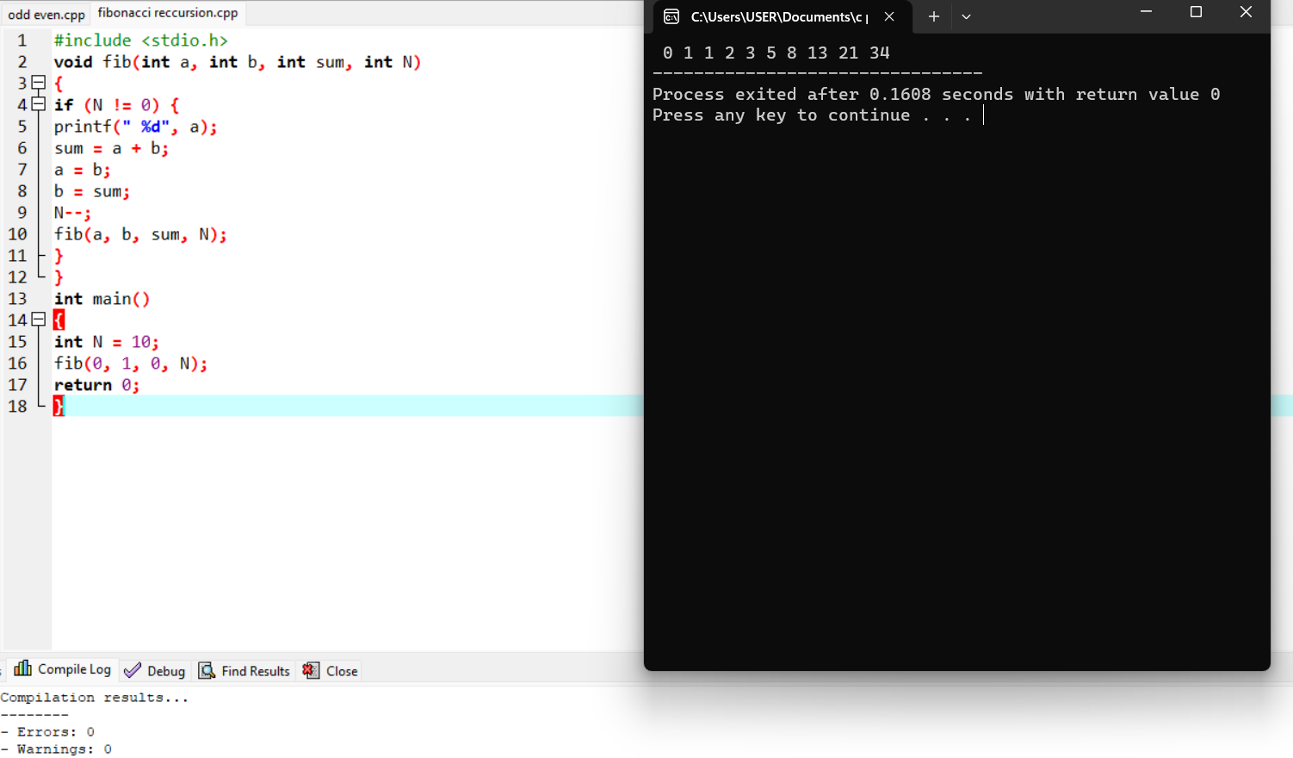

**8.factorial using reccursion**

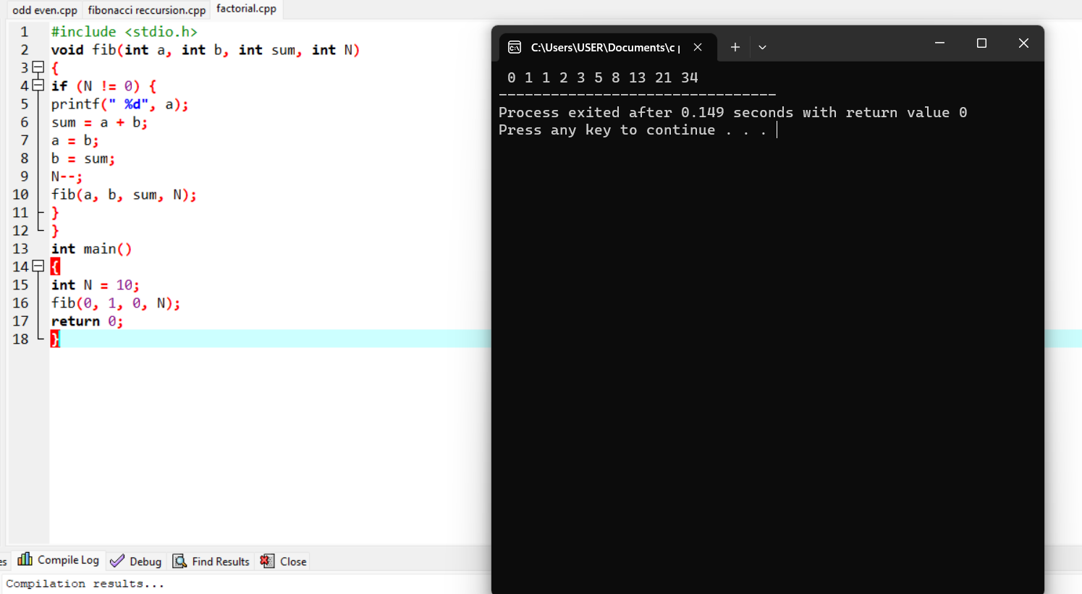

9. factorial

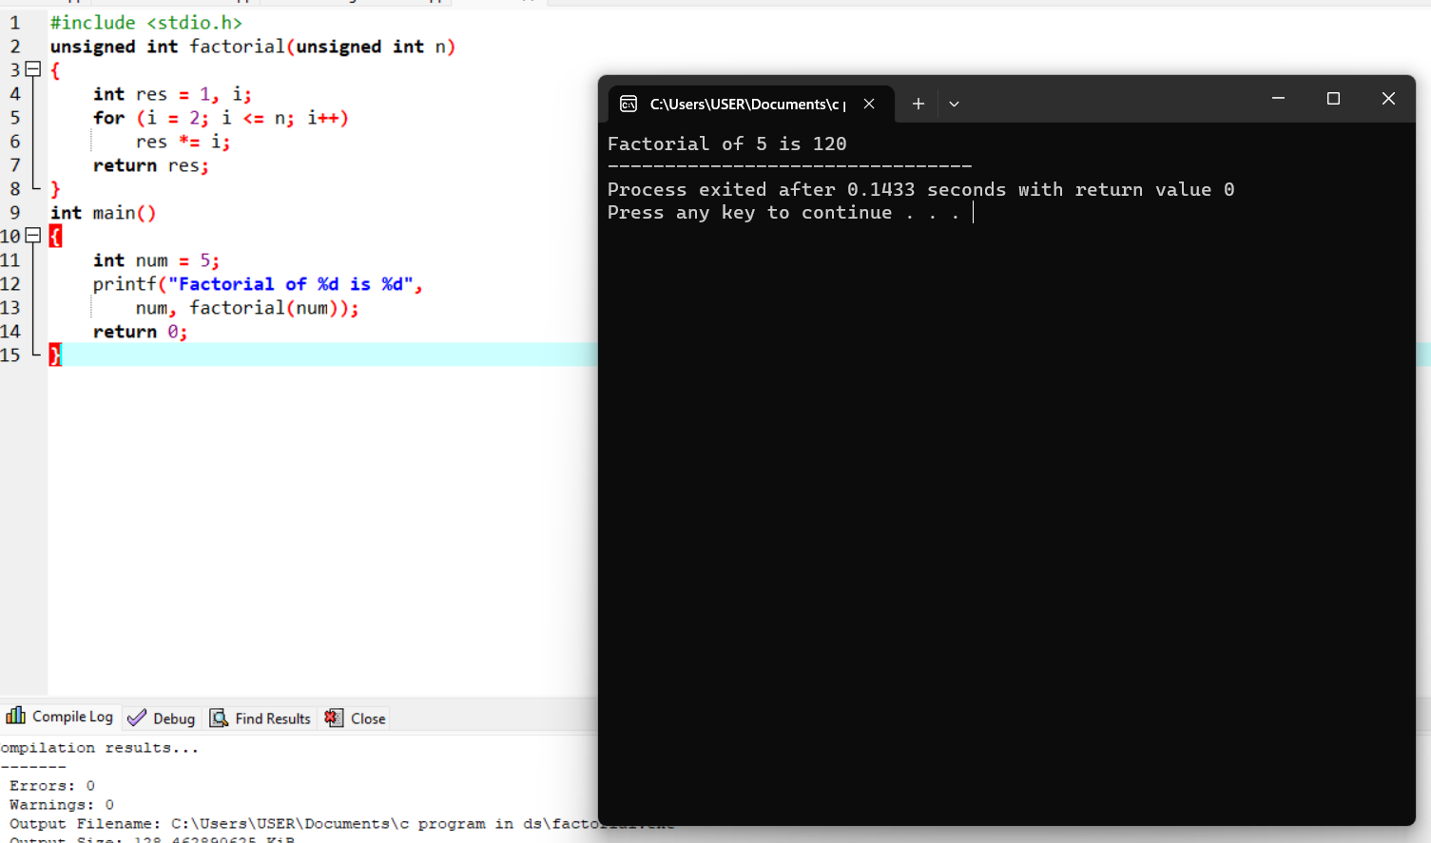

# 10. KRUSKALS Algorithm



11. Binary search tree

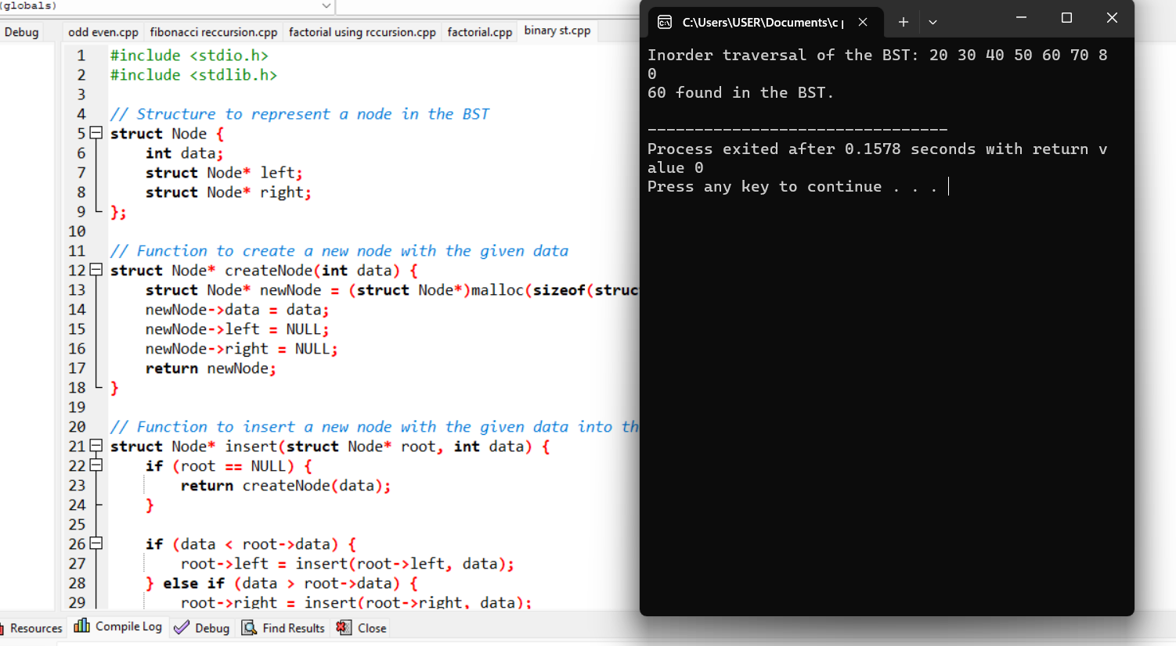

12. deleting an element in bst

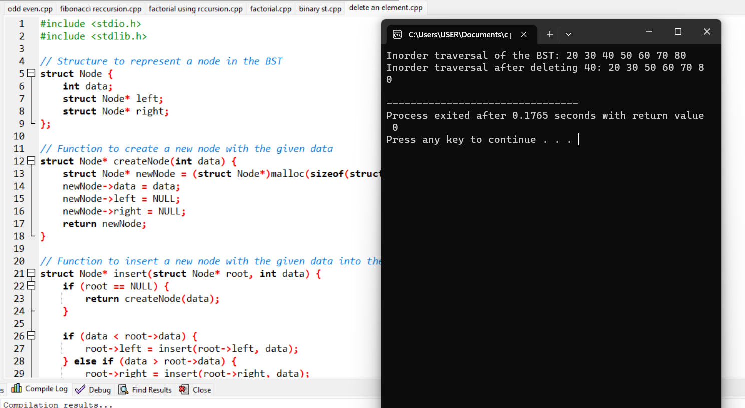

13. heap sort

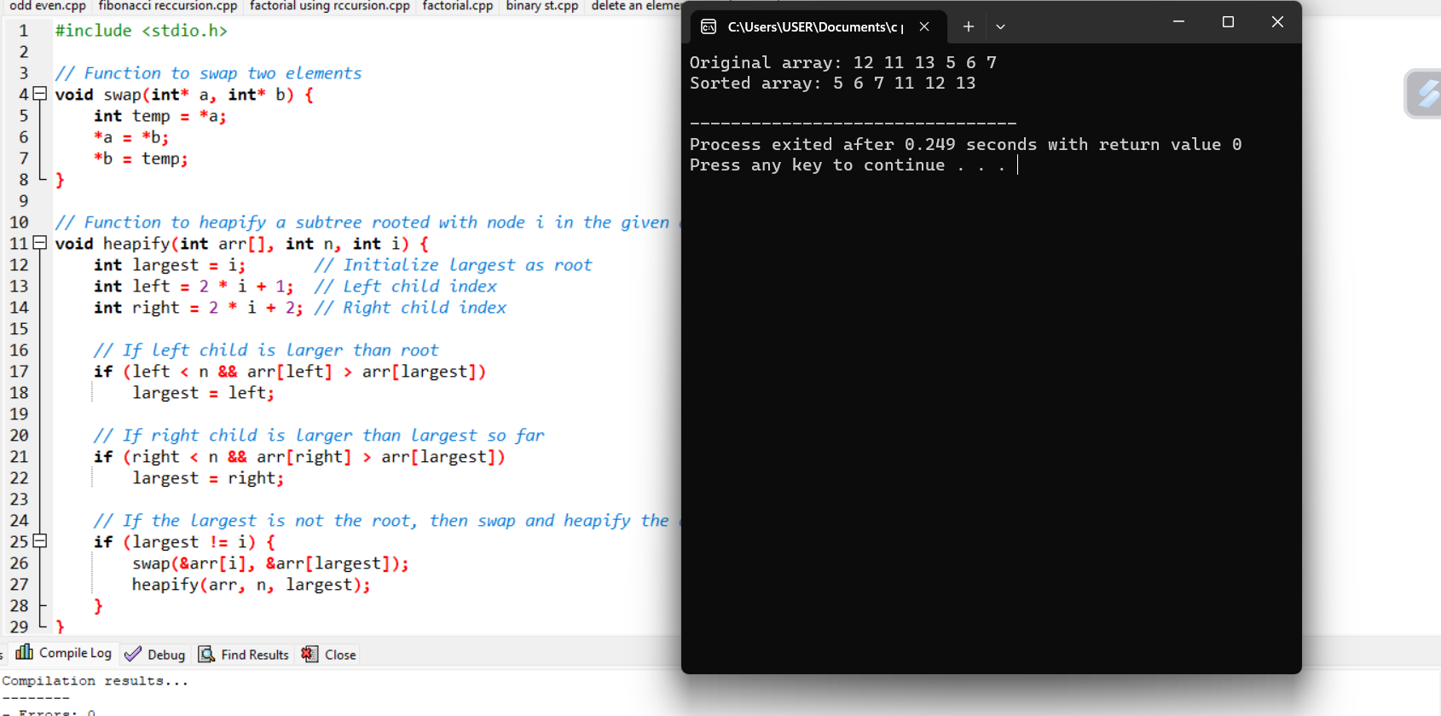

14.Linked list

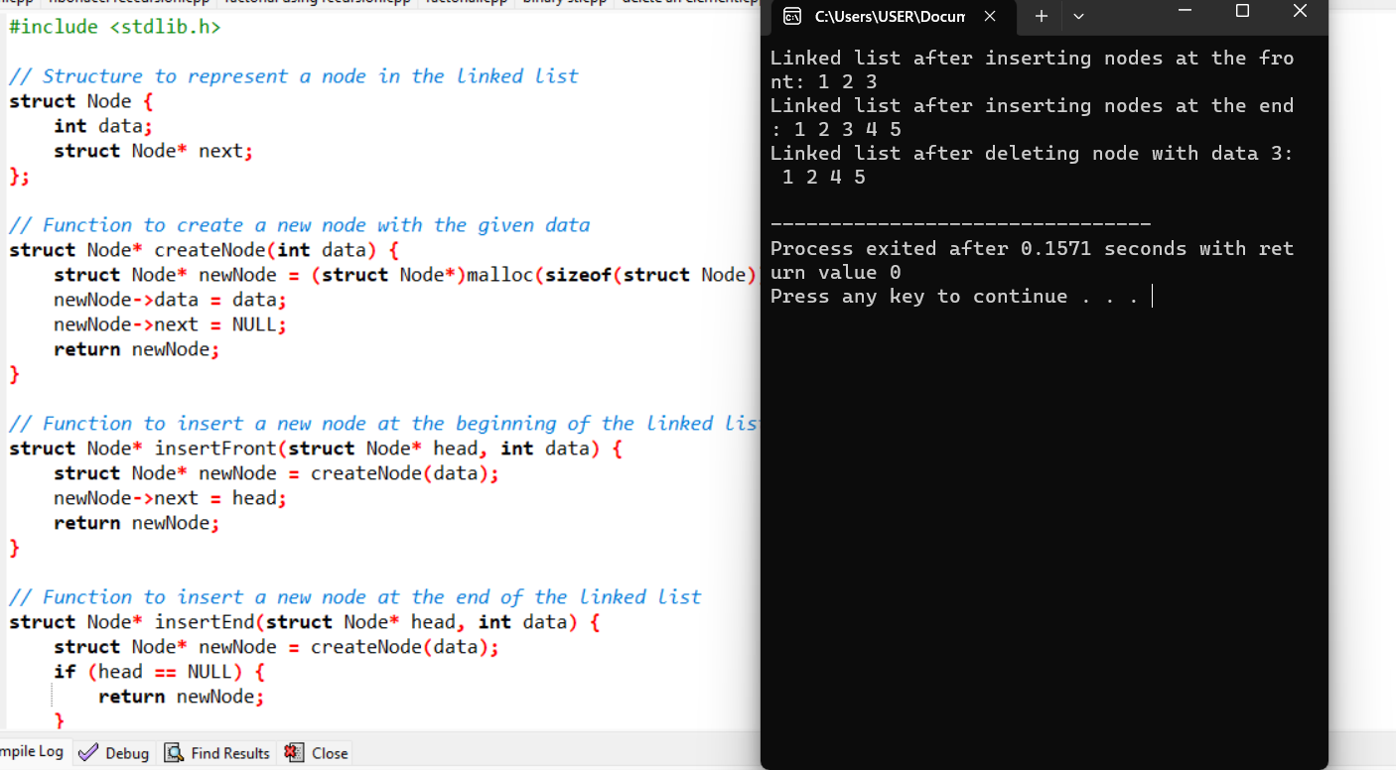

15. matrix multiplication

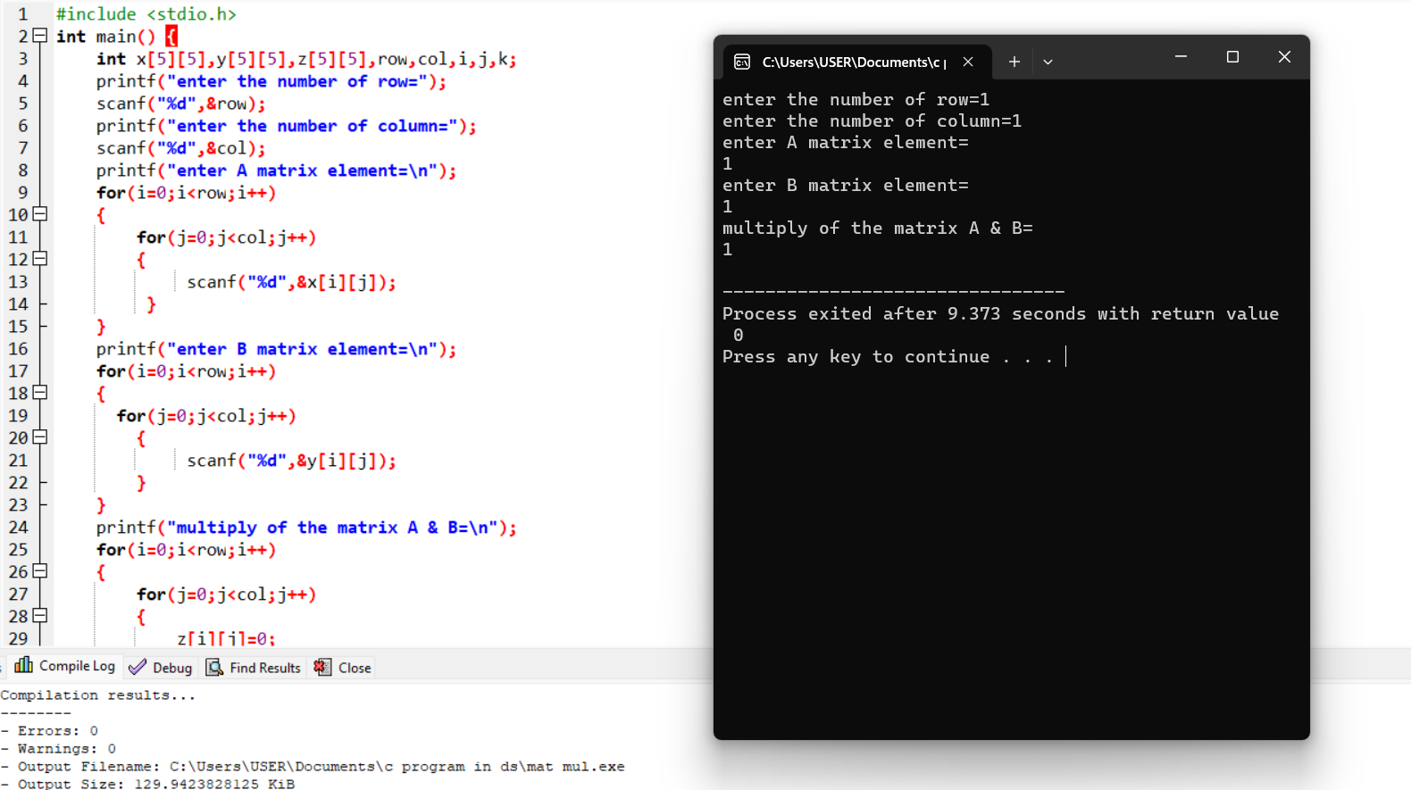

16.merge sort

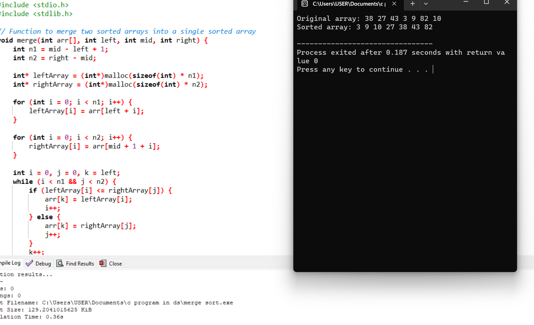

17. insertion sort



18.prims algorithm



19.que sort



20 . que operations

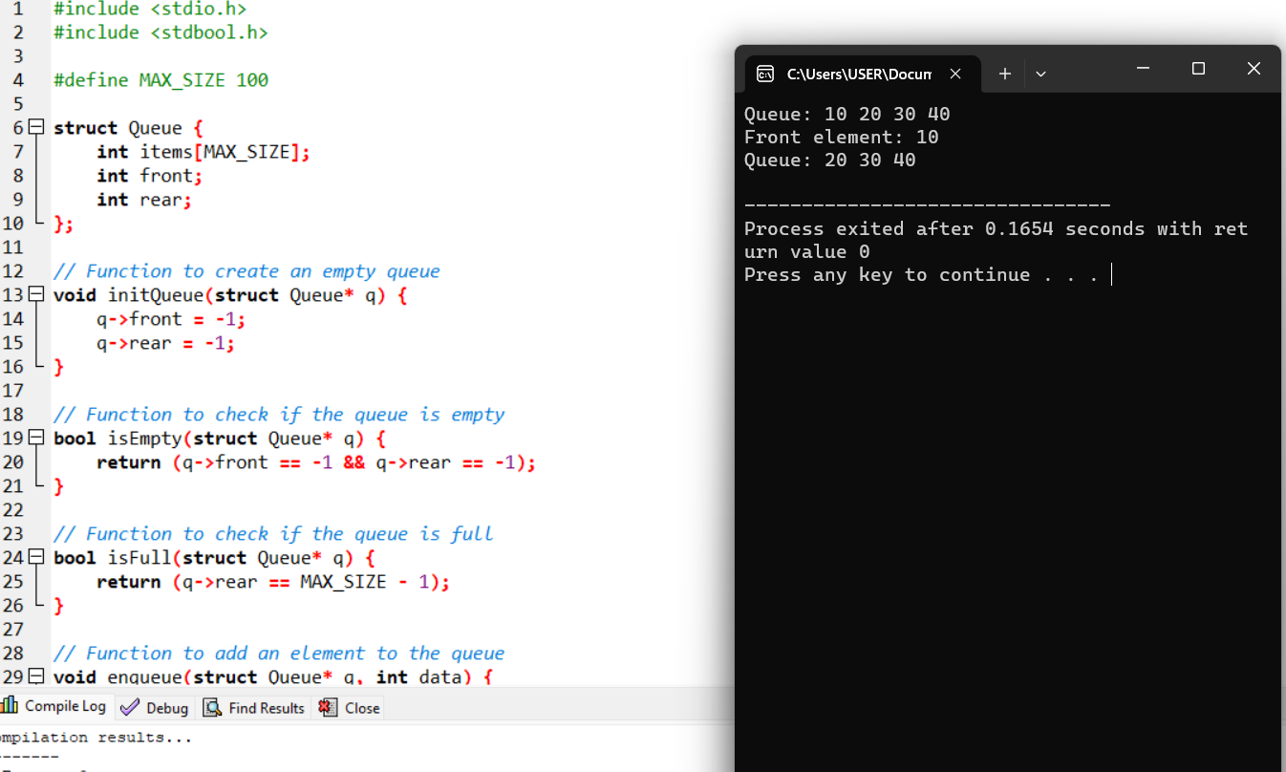

21. stack application

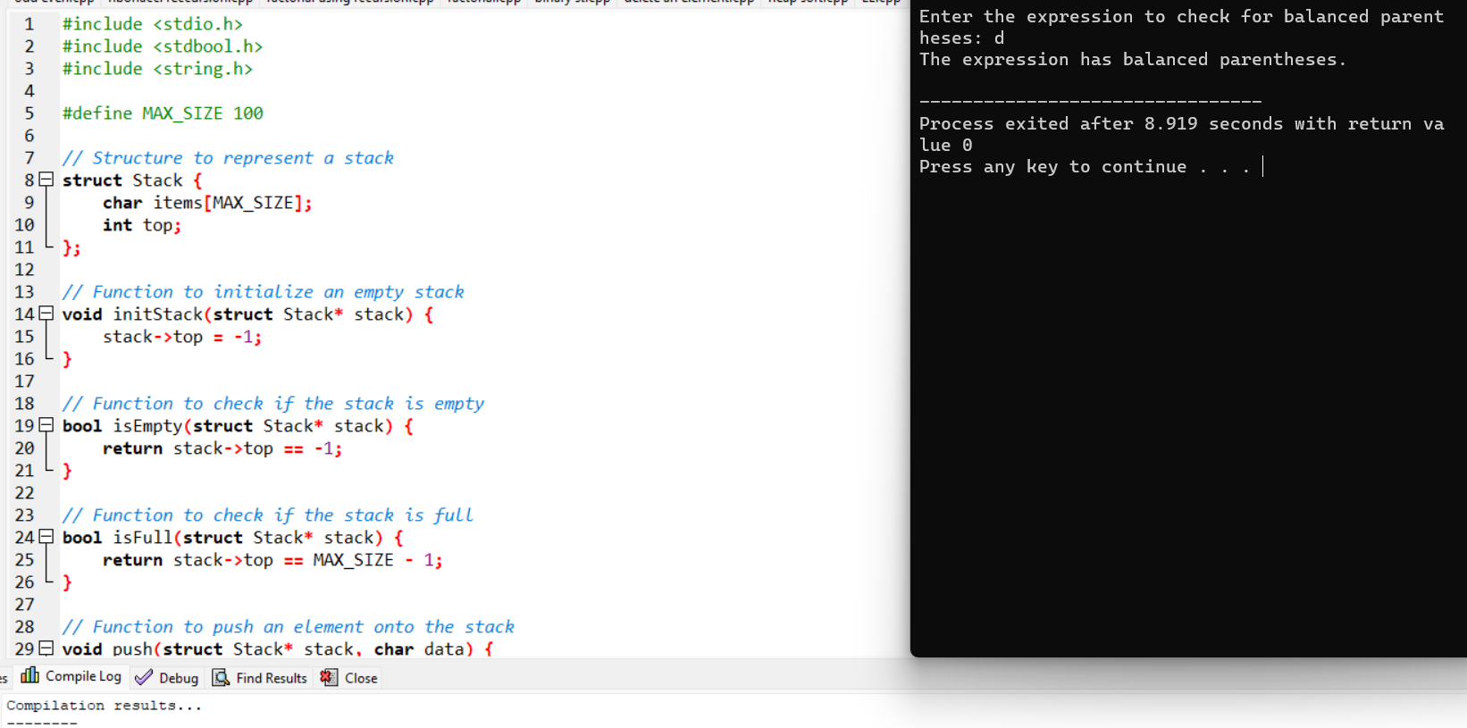

22. stack operators

